4.46: a) His speed as he touches the ground is

b) The acceleration while the knees are bending is
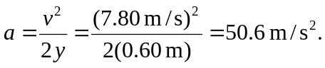

c)
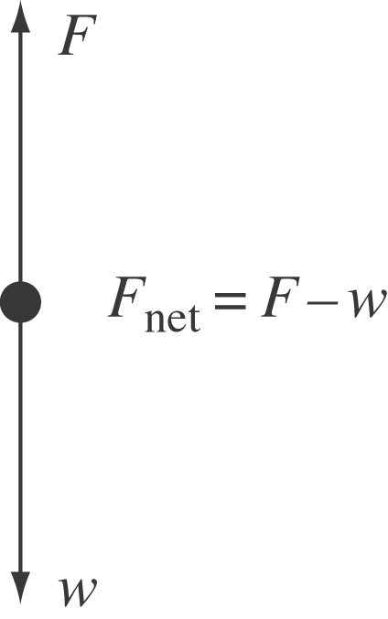

The net force that the feet exert on the ground is the force that the ground exerts on the feet (an action-reaction pair). This force is related to the weight and acceleration by 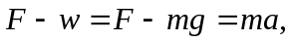 so. As a fraction of his weight, this force is 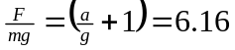 (keeping an extra figure in the intermediate calculation of a). Note that this result is the same algebraically as 

